**Interim Report**

**Level 4**

**Sappu Savari - Location Based Advertising & Marketing**

I S Dewasurendra

139160M

**Supervised by:** Mr Saminda Premaratne

Faculty of Information Technology

University of Moratuwa

2015

**Interim Report**

**Level 4**

**Sappu Savari - Location Based Buying & Selling System**

I S Dewasurendra

139160M

**Supervised by:** Mr Saminda Premaratne

Faculty of Information Technology

University of Moratuwa

2015

**Abstract**

People use different types of media to advertise. Some people advertise to sell something and some people advertise to buy something. Everyone have their different types of needs. In early ages mostly newspapers were used to post advertisements to sell or buy different types goods and services. But later with the tremendous success of the internet, the World Wide Web, mobile communication and different kinds of software were used to advertise different type of goods and services such as Vehicles, houses, lands and so on. Those were advertised in through systems and there were huge audience through the internet. Later World Wide Web integrated with mobile communication and became the main advertising media to sell or buy.

When the systems get expands the no of posts or advertisements are increasing in higher rates. Users spend several hours to search the advertisements to find the best matching for their needs. So systems integrated with some advanced search functionalities to help to find the best match, but still users have to keep searching every time since new advertisements are popping up in each seconds.

‘Sappu Savari’ is the new proposed system which is more helpful and interactive to the users. People can easily use this new system in their mobile phones, tablets or laptop computers. The main promise of the mobile related technology is to satisfy user needs for anywhere, anytime access to information and services, including Location Based Services (LBS). The system will keep searching automatically, match with the given details and notify the best match to the users. User doesn’t need to browse through the long list of available advertisements and find the best matching goods or service. While user (buyer/seller) on the move system always tracking the location of the user and notify nearby goods and services with relevant details to buy or sell. User will be able to easily contact the other party and could be able to meet using generated map route.

This concept will leave the user free and save lot of time. System will be able to track down all the advertisements according to the given required details and provide a reliable and interactive way of tracking the locations according to the advertisements. System will be read the locations by the available sensors of the devices which are used by the users. Nearby locations will be notified to the users and give alerts with summarized details. This will allow users to find and meet the buyers or sellers on their way.

The system will be automated to search advertisements and tracking the locations according to the available details.

The technologies adopted for this design are based on open standards and can be successfully meet the requirements of the user needs.

Table of Contents

Chapter 1 1

Sappu Savari - The Next Level of Mobile Marketing 1

1.1 Introduction 1

1.2 Background 2

1.3 Aim and Objective 4

1.4 Proposed System 5

1.5 Summary 7

Chapter 2 8

Existing Issues in Internet Based Advertising Systems 8

2.1 Introduction 8

2.2 Existing Location Based Systems 8

2.3 Summary 15

Chapter 3 20

Beyond Internet Advertising and Marketing 20

3.1 Introduction 20

3.2 Mobile Communication – Beyond Internet Marketing 20

3.3 Summary 23

Chapter 4 24

Sappu Savari – The Revolutionary Concept of Advertising 24

4.1 Introduction 24

4.2 Approach 24

4.3 Summary 27

Chapter 5 28

Sappu Savari – The New Mobile Oriented Architecture 28

5.1 Introduction 28

5.2 Analysis and Design 28

5.2.1 Scope 28

5.2.2 Design Considerations 29

5.2.3 Detailed Software Architecture and Technology Stack 31

5.2.4 Detailed Component Design 33

5.2.5 Detailed Program Sequence 33

5.2.6 Detailed Program Specification 34

5.2.7 Deployment View 35

5.2.8 Implementation Model 35

5.3 Summary 36

Chapter 6 37

Sappu Savari – Implementation 37

6.1 Introduction 37

6.2 Implementation of the Sappu Savari 37

6.3 Summary 38

Chapter 7 39

Discussion 39

7.1 Introduction 39

7.2 Discussion 39

7.3 Summary 40

Chapter 8 41

References 41

Chapter 9 44

Appendix 44

9.1 Appendix A – Sequence Diagrams 44

9.1.1 Login User 44

9.1.2 Post Advertisement 44

9.1.3 Search Advertisement 45

9.1.4 Rank Advertisement 45

9.1.5 Comment on Advertisement 46

9.1.6 Mark Favorite Advertisement 46

9.1.7 Send Messages 47

9.2 Appendix B 48

9.3 Appendix C 49

**List of Figures/Tables**

Figure 1: Table of Feature Comparison 16

Figure 2: Table of User Roles and Duties 28

Figure 3: Software Architecture 31

Figure 4: Table of Available Components 32

Figure 5: Technology Stack 32

Figure 6: Component Design 33

Figure 7: Deployment View 35

Figure 8: Table of Package Structure 35

Figure 9: Table of Folder Structure 36

Figure 10: Login User - Sequence Diagram 44

Figure 11: Post Advertisement - Sequence Diagram 44

Figure 12: Search Advertisement - Sequence Diagram 45

Figure 13: Rank Advertisement - Sequence Diagram 45

Figure 14: Comment on Advertisement - Sequence Diagram 46

Figure 15: Mark Favorite Advertisement - Sequence Diagram 46

Figure 16: Send Messages - Sequence Diagram 47

Figure 17: Class Diagram 48

Figure 18: ER Diagram - Database Level 49

# Chapter 1

## Sappu Savari - The Next Level of Mobile Marketing

### Introduction

These days new smartphone applications all seems to want the same thing from us—our latitude and longitude. Three-quarters of America’s smartphone owners use their devices to retrieve information related to their location driving directions, dining suggestions, weather updates, the nearest ATM. Such location data is a boon to advertisers, who use information on our movements to discern our habits and interests, and then target ads to us [1]. With the addition of GPS and cellular technology, advertising can makes more interactive to the users.

But advertising and marketing software systems don’t use this geo location information to trace users. There is few systems uses geo location specific for shop or a place not for a user. This means every seller should have shop or a place for marketing or advertising. But in real world people sell their old electronic items, vehicles, books through these systems and they don’t have an exact place to geo locate. In this scenario almost every advertising system failed to provide a proper geo location based marketing. But newly proposed “SappuSavari” system is capable of tracing individual users who are acting as sellers or buyers in the system perspective and provide notifications when there are advertisements that match and nearby.

The new proposed system is more helpful and interactive to the users for advertising. People can easily use this new system in their mobile phones, tablets or laptop computers. The main promise of the mobile related technology is to satisfy user needs for anywhere, anytime access to information and services, including Location Based Services (LBS) [2]. The system will keep searching automatically, match with the given details and notify the best match to the users. User doesn’t need to browse through the long list of available advertisements and find the best matching goods or service. While user (buyer/seller) on the move system always tracing the location of the user and notify nearby best matching goods and services with relevant details. User will be able to easily contact the other party and could be able to meet using generated routes on a map.

This concept will leave the user free and save lot of time. System will be able to track down all the advertisements according to the given required details and provide a reliable and interactive way of tracking the locations according to the advertisements. System will be reading the locations by the available sensors of the devices which are used by the users. Nearby locations will be notified to the users and give alerts with the summarized details. This will allow users to find and meet the buyers or sellers on their way.

### Background

Location aware advertising opens up new frontiers for brands to place their advertisements in front of consumers at or near the place where they can obtain them; thanks to the ubiquitous nature of mobile. In the most basic sense, if an ad server is made aware of a user’s location, then a decision can be made to deliver an advertisement based on either the user’s current location, or a history of where they have been, coupled with a user profile of their interests.

While the often used “Starbucks example” sounds exciting – you’re walking past a Starbucks and you get an SMS for a free coffee, it is unlikely that this would ever work in practice. Importantly in this example, Starbuck don’t discount their coffee, or have a loyalty program and in cities like London they are simply everywhere [3].

A more likely another use case which location services could be used for a movie chain. They most likely will have a movie club and a list of subscribers who have opted in to receive movie news and discounts. If the movie chain wished to fill seats on a slow Thursday afternoon, they would want to know how many of these opted-in members are near one of their cinemas. Importantly, they do not want to know if they are actually at the cinema (then there is no point in sending them an offer as they are already there seeing a movie), but if they are close enough, and the offer is compelling enough (e.g. 50% off any movie in the next 30 minutes) then they are more likely to respond to the offer – creating a very targeted, and instantly successful marketing campaign.

As we know most of companies put there step forward to begin marketing and advertising via mobile phones. So this era is the best to use mobile based technologies to use for our day to day life. Smart phones became very common and mobile internet became a mandatory for the human life. People tend to use mobile phones for everything they want. In this scenario location based services is becoming mandatory for advertising systems. But in real life there are so many obstacles to use location based services, but there are ways which we can use them reliably and efficiently.

There are few systems available with LBS (Location Based Service) used for advertising purposes in some countries.

They are,

* ‘Closs 5’ is a consumer to consumer online marketing application developed by EBay. This application allow user to find consumers in their region and online chat with the other party regarding the trade. Even though this closs 5 application uses LBS on their system, they used it to categories the goods and services not to trace the consumers [4].
* ‘Yardsale’ is an iOS location-based app made buying and selling easily. This application allows users to post advertisements for goods and services to buy or sell. It shows what type of goods and services around buyer’s location in a list view. This application detects only the fixed locations and doesn’t provide any information to find the other trade party by route details using maps [5].

Also there are some advertising systems with in Sri Lanka, which are very famous in Sri Lankan society.

They are,

* Ikman.lk – users can post advertisements based on different product categories. Advertisements are categorized using locations. Users can search advertisements on specific locations such as Galle, Colombo, Dehiwala, etc. Still location is a constant and only uses for categorize the advertisements.
* HitLanka – users can post advertisements just like the previous system. Advertisements are categorized by the locations and don’t provide any location based services.

As you can see location based services are not been used for advertising and marketing systems in Sri Lanka.

By reviewing the existing systems and their missing functionalities are well identified and have a very good approach by using new technological advantage to the new proposed system.

### Aim and Objective

Aim of this newly proposed system design is to minimize the user involvement and automate the advertisement searching and trace the buyer/seller using the Location services available in mobile devices. This will reduce the time consuming tasks and allow using the services more efficient and reliable.

Sappu Savari will be provided efficient and reliable service to every type of buyers and sellers by reaching below objectives,

* Providing user friendly web/mobile client to access the system functionalities such as posting or reading buyer/seller information, ranking the seller, search options to find advertisements. .. etc.
* Tracing user location continuously using Location Based Services and provide relevant route details to find the buyer or seller.
* Minimize the time and effort of browsing through lists of available advertisements by providing automated process of finding best matching parties for the trade using available information in the system.
* Backend services with capabilities of handling huge amount of information related to marketing and its categories.
* Allow users to access the system with almost any devices with Internet capabilities.
* Automate the searching and provide continuous feedback according to the specific user’s request.

### Proposed System

The proposed system is conceptually simple and amazingly efficient as a marketing service. Simply the most of the process are automated and users are seeing and visible advertisements accordingly. The services are very effective and most users are benefited by automated descriptive services.

The proposed system is supporting the services that described above and have the following characteristics:

* The system mainly using web protocols which means system functions as a web oriented system via internet.
* Server side of the system is developed by Java and platform independent (can work on windows/Linux).
* Client side of the system is platform independent (can work on windows /Linux /android /apple/ ...etc.) and device independent (smart phone /tablet /laptops /workstations / ...etc.)
* Various types of devices can be connected to the system according their internet capabilities. Availability of the sensors and performance system may vary the accuracy and the speed of the responses. Since the system services depend on the geo location of the users; devices with Location services are recommended for higher accuracy and efficiency.
* Every user need to create an authentication to save and retrieve relevant information.
* System is developed over three tier architecture for support distributed database systems for better performance.
* Spring framework used for system development which is provide security, scalability and performance.
* Databases and Services developed and designed over Open Source Technologies such as Java, Jasper, Tomcat, etc.
* Uses geo location services on browsers to locate the users, so system can get the location even on IP based information(less accurate on IP based information and high accuracy when GPS is available [6])
* Users are free to use any type of browsers since it supports geo location API. Most of the existing browsers are compatible with the geo location API [7].
* Uses Google map API for generate maps and route [8].

The above system has been designed and implemented by following well defined standards. So the same design structure and the technologies can be used to against real world conditions.

The remainder of this paper is organized as follows. In the next chapter I will provide the basic information of the mobile marketing and existing tools. Next chapter includes the technological information and the way of approach to the existing mobile marketing systems with better suggestions. In chapter 4 includes my new approach to the internet based advertising. In chapter 5 I will provide the problem analysis and the design of the solution in detail which describe the usage of the available technological components work together to provide a better service to the users.  Next chapter includes all the relevant information regarding the implementation of the system. In the last section includes my conclusion on my newly proposed concept and discuss what is going to develop in the future.

### 1.5 Summary

Location based services are used all over the world for many different software systems. Most of the advertising and marketing software systems also use location based services but only of market a land marked shop. The newly proposed systems main approach is to use location based services in a way of supporting users to meet each other to complete their trade.

Also automate the search advertisement process over user interests and pre searched information will save time and effort. Except above there are few more newly proposed features in the system such as rank, comment, mark as favorite, etc.

In the next chapter I will discuss about the few of existing advertising and marketing software systems in Sri Lanka and some other countries. Mainly the drawback of these systems and how our new approach is overcome these drawbacks.

# Chapter 2

## Existing Issues in Internet Based Advertising Systems

### Introduction

This chapter will give you an idea about the existing internet based advertising software systems, How they advertise their advertisement how they manage to market those advertisements in the community within their system, How they used new technologies like mobile location services and other functionalities which supports the users to do their tasks easily. Again this chapter will highlight the existing issues in those systems and how the new proposed concept solves over.

There are lots of existing advertising software systems around the world. Some of them are very famous and have thousands of users around the world. In Sri Lanka there are lot of people who uses these type of systems. Some IT related companies tend to build these types of systems and currently they are executing them successfully. In this chapter I will select few systems in Sri Lanka as well as around the world to have a conclusion which area should missed in these application and how should I approach to those missed functionalities.

### Existing Location Based Systems

#### Ikman.lk

##### **What is Ikman.lk?**

ikman.lk is a website where you can buy and sell almost everything. The best deals are often done with people who live in your own city or on your own street, so on ikman.lk it's easy to buy and sell locally. All you have to do is select your region.

It's completely free to publish a classified advertisement on ikman.lk, and it takes you less than 2 minutes. You can sign up for a free account and post advertisements easily every time.

ikman.lk has the widest selection of popular second hand items all over Sri Lanka, which makes it easy to find exactly what you are looking for. So if you're looking for a car, mobile phone, house, computer or maybe a pet, you will find the best deal on ikman.lk.

ikman.lk does not specialize in any specific category - here you can buy and sell items in more than 50 different categories. Ikman.lk also carefully reviews all ads that are being published, to make sure the quality is up to our standards [9].

* + - 1. **Existing Issues in Ikman.lk**

Even though there are vast community already using the ikman.lk internet advertising system for their advertising purposes, there are few issues exist which is not solved so far.

The few of them are as follows:

* Buyer cannot rate the products or give a comment about it.
* Users cannot share the advertisement over social media; System doesn’t provide the proper facilities for this.
* Buyer has to find the specific products using the search options over many categories. System itself not response for newly added advertisements after the search results retrieved. As an example a buyer finds a red color yamaha 200cc motor bike in the morning, but he/she couldn’t find any advertisement on above type of motor bike. But in the evening a seller post an advertisement on exactly the wanted type of motor bike. But the buyer is not notified and doesn’t know that an advertisement is already posted which is exactly matching. So the buyers have to search the product or service every time to find the best and newest advertisements. Due to this reason users waste much time to search their products and services.
* Advertisements are categorized over product type and address. So buyers search products or services on specific district or area. But using this constant buyers and sellers misses most of the matching advertisement all the time. As an example a seller in Jaffna post an advertisement to sell his car in the system under district Jaffna. A buyer from Colombo searches a same type of car in Colombo area; and Jaffna seller’s advertisement never been picked for the search criteria. But if Jaffna seller moved to Colombo for two days, buyers in Colombo can easily can check the car and meet the seller, but unfortunately still Jaffna seller’s advertisement doesn’t picked for Colombo buyer's search criteria. This type of issues happens always and never been given solution from existing advertising systems.
* Buyers and sellers are capable of post text and images for the advertisement. Seller can post his/her mobile number to contact him/her. But buyers have to allocate time and a place to meet the seller and check the product before buy. Due to this reason users have to spend lot of time meet the other party and check the product or service.
  + 1. **Oodle Marketplace – United States**
       1. **What is Oodle Marketplace?**

Using the power of social media, Oodle is reinventing online classifieds. Oodle provides consumers with a friendly local marketplace to buy sell and trade. Oodle operates a network of online marketplaces with more than 15M monthly unique users including the [Oodle Marketplace](http://oodle.com/).

Have something you are not using? Sell it or give it away! It's as easy as snapping a picture. Your items will instantly be posted on Oodle. See what your friends on Facebook are selling, giving away or looking for. Someone may have extra tickets for tonight's big show! Looking for something specific or a great deal? Quickly search through thousands of nearby listings from Oodle, Marketplace on Facebook and Craigslist.

Oodle Marketplace is currently available for the iPhone & Android [10].

* + - 1. **Existing Issues Oodle Marketplace**

Even though there are vast community already using the Oodle marketplace in UK as their internet advertising system for their advertising purposes, there are few issues exist.

The few of them are as follows:

* Buyer cannot rate the products or give a comment about it.
* Same as the ikman.lk software system advertisements are categorized over product type and address. So buyers search products or services on specific district/area. But using this district and area as a constant buyers and sellers misses most of the matching advertisement all the time.
* Buyers and sellers are capable of post text and images for the advertisement. Seller can post his/her mobile no to contact him/her. But buyers have to allocate time and a place to meet the seller and check the product before buy. Due to this reason users have to spend lot of time meet the other party and check the product or service.
  + 1. **HitLanka**
       1. **What is HitLanka?**

Hitlanka.com is no.1 free online classified ads website in Sri Lanka, a place where people can associate with one another to buy or sell products and services free in Sri Lanka and globally as well. Our website was launched in 2008 with the vision for buyers and sellers to “meet online, finalization offline”, today HitLanka have over thousands of listings.

Headquartered in Colombo, Sri Lanka, hitlanka.com is accessed by more than 75% unique users and thousands of new customers every week. HitLanka, now have over 27 categories and of them are, HOUSE FOR RENT | HOUSE FOR SALE | REAL ESTATE | RENT A CAR | AUTOMOBILE | TOURS/TRAVEL | FASHION/BEAUTY | HEALTH/FITNESS |FURNITURE | COMPUTERS AND ACCESSORIES | PHONES | OTHERS | MOTORBIKES | ANTIQUES AND COLLECTABLES | SPECIAL PROMOTION | SPORT GOODS | KIDS’ TOYS |JOBS | FOOD & AGRICULTURE | PETS | EDUCATION | SERVICES | HOME & PERSONAL ITEMS | CLOTHES, FOOTWEAR, JEWELLERY & ACCESSORIES | ELECTRONICS | MOVIES, BOOKS MAGAZINES|TICKETS| HOBBY & LEISURE.

At hitlanka.com, HitLanka have formed an online community which is simple and safe. HitLanka is continuously modernizing so that users can buy and sell in the easiest and most suitable way possible. It's totally free to post classified ads on hitlanka.com, and it takes you less than 2 minutes. To make the visibility of your advertisement high for our users, paid ads are also available on hitlanka.com [11].

* + - 1. **Existing Issues in HitLanka**

Even though there are vast community already using the hitlanka.com as internet advertising system for their advertising purposes, there are few issues exist which is not solved so far.

The few of them are as follows:

* Buyer cannot rate the products or give a comment about it.
* Buyer or sellers cannot share the product or services over social media; the system is not providing proper facilities for this.
* Buyer has to find the specific products using the search options over many categories. System itself not response for newly added advertisements after the search results retrieved. As an example a buyer finds a red color Yamaha 200cc motor bike in the morning, but he/she couldn’t find any advertisement on above type of motor bike. But in the evening a seller posts an advertisement on exactly the wanted type of motor bike. But the buyer is not notified and doesn’t know that an advertisement is already posted which is exactly matching. So the buyers have to search the product or service every time to find the best and newest advertisements. Due to this reason users waste much time to search their products and services.
* Same as the ikman.lk software system advertisements are categorized over product type and address. So buyers search products or services on specific district or area. But using this district and area as a constant buyers and sellers misses most of the matching advertisement all the time.
* Buyers and sellers are capable of post text and images for the advertisement. Seller can post his/her mobile number to contact him/her. But buyers have to allocate time and a place to meet the seller and check the product before buy. Due to this reason users have to spend lot of time meet the other party and check the product or service.
  + 1. **Marketplace**
       1. **What is Marketplace?**

marketplace.lk is a website where you can buy, sell and rent almost everything. All you have to do is select your region. It's completely free to publish a classified ad on marketplace.lk, and it takes you less than 2 minutes. You can sign up for a free account and post ads easily every time.

marketplace.lk is a fast growing web site in Sri Lanka, that's why it easy to find exactly what you are looking for. So if you're looking for a car, mobile phone, house, computer or maybe a pet, you will find the best offers on marketplace.lk.

With marketplace.lk you can buy, sell and rent items in more than 40 different categories. Marketplace also carefully reviews all ads that are being published, to make sure the quality is up to our standards [12].

* + - 1. **Existing Issues in Marketplace**

Even though there are vast community already using the marketplace.lk internet advertising system for their advertising purposes, there are few issues exist which is not solved so far.

The few of them are as follows:

* Buyer cannot rate the products or give a comment about it.
* Buyer or sellers cannot share the product or services over social media, The system is not providing proper facilities for this.
* Buyer has to find the specific products using the search options over many categories. System itself not response for newly added advertisements after the search results retrieved. Due to this reason users waste much time to search their products and services.
* Same as the ikman.lk software system advertisements are categorized over product type and address. So buyers search products or services on specific district or area. But using this district and area as a constant buyers and sellers misses most of the matching advertisement all the time.
* Buyers and sellers are capable of post text and images for the advertisement. Seller can post his/her mobile number to contact him/her. But buyers have to allocate time and a place to meet the seller and check the product before buy. Due to this reason users have to spend lot of time to meet the other party and check the product or service.

### Summary

Most of the existing internet based advertising systems have same kind of issues. These issues have not been resolved so far due to many reasons. So the newly proposed “Sappu Savari” addresses these issues with reliable and robust solutions. The concept behind the “Sappu Savari” is simple but efficient for every uses both seller and buyer.

Please find below common and well known issues and the way of address the same issue with the newly proposed “Sappu Savari” mobile oriented advertising classification system:

Figure 1: Table of Feature Comparison

|  |  |
| --- | --- |
| Common Issues | Approach of the newly proposed concept |
| User doesn’t get notification when there are new matching advertisements available according to his/her search criteria. | This is very important; users always spend lot of time to search the products or services he/she wants. Sometimes users browse or search the lengthy list over and over again to search the best matching products. What if user gets relief from this and notifies users when there are any matching products or services. Automating this process will help the user to save lot of time.  “Sappu Savari” keeps the information of searches and save them as search requests in the system. Then automated process is searching the available advertisements periodically to check whether there any matching advertisement to the user's search requests. If there any system provides notifications to the users. Rather than searching the advertisements every time, user can search the product when there any notifications. This will help users to save their time and money to spend particular sellers. |
| Buyers don’t get notification when there are any sellers are available nearby. So chances of meeting the seller personally miss. | This is also an important feature that must have in an advertising system. Most of the buyers need to meet the seller personally and check the device before preceding the payments.  According to the search request functionality in “Sappu Savari” system always keeps the information regarding the searches of specific users. System processes always keep following the existing advertisements to match the best matching advertisements. Also system keeps tracing the seller geo location as well. When the sellers location is nearby for specific selected advertisements system gives notifications, and then seller can find the buyer using generated route maps to the buyer location.  Using this proposed concept buyers can find sellers even when they travel, No need to call or email to the seller to allocate time for personally meet and check the product or services. This automated process saves lot of time for buyers. |
| Keeping the product or service location as a constant will miss lot of opportunities to sell or buy products. | Existing systems store all the advertisements under several category types. One of the main categories is the location parameter. Advertisements are categorized and grouped according to the location. System search functionality always uses these groups to retrieve advertisements when searching on specific locations.  So buyers search products or services on specific district or area. But using location as a constant buyers and sellers miss most of the matching advertisement all the time. As an example A car seller in Nuwara Eliya post advertisement in the system, buyer in Colombo searches cars in Colombo area. But if the seller came to Colombo for any reason, still Colombo user cannot pick the Nuwara Eliya seller. The problem in this situation is systems keep the location as a constant; these systems couldn’t dynamically change the advertisement location due to unavailability of a way to identify the location of the seller/buyer.  In “Sappu Savari” system I always get the user's geo location from the devices they logged in to the system. In the search algorithms this dynamically updated location is always picked. As an example even seller post his/her advertisement in the Nuwara Eliya, if he/she is travelled to Colombo; system categorize the seller in to Colombo district and nearby locations. So buyers never miss any sellers who they nearby. |
| Cannot rank the product or services according to the user experience. | Most of existing advertising systems don’t allow users to rank the seller or comment. So buyers cannot have a genuine idea about the sellers, if buyers can always take correct decisions before proceeding to buy the products and do the payments.  So “Sappu Savari” allows users to rank the advertisements, and the higher ranks always have the priorities over other advertisements. Also users can comments on specific products or services; this allows communicating between buyers before buying any products or services.  Also this concept will reduce the frauds. Sellers always try to do their best to maintain the customer satisfaction at the highest level; otherwise their business will be lost. Also any buyer can have a general idea about the seller according gained rank and other user’s comments. |
| Most of the systems are optimized and tuned for laptop computers and desktop computers, simply for bigger screens. But bigger portion of the community uses mobile phones and tablets. | “Sappu Savari” is optimized for any mobile platform such as Android, Apple, Windows or Blackberry. Also system is capable of viewing any screen size available in the devices. Also system is capable of read the geo location information from any device through browsers, do depend on the device capabilities system can get most accurate geo location information. |

In next chapter I will provide information about the type of technologies are available for the newly proposed concept. Mainly the way of communication via mobile and how they developed over past years and what is the best to the design of the “SappuSavari”.

# Chapter 3

# Beyond Internet Advertising and Marketing

### Introduction

In previous chapter I discussed about the existing advertising systems and their drawbacks; and how I am going to overcome those. In this chapter I am going to discuss about how technological background behave related to the proposed system.

I am going to discuss about what type of technologies which I used how they should be used and why those technologies are selected over other existing technologies.

### Mobile Communication – Beyond Internet Marketing

Advances in wireless communication and information technology have made the mobile web a reality. Mobile web should respond to the need for anytime, anywhere access to information and services. Many software applications were deployed and available to customers via mobile phones and wirelessly connected tablets/PDAs. Except mobile web, services such as Location Based Services are promising technologies which are always providing important and interactive information to the users.

In 2000 Gravitate Inc. has published a white paper which identifies three evolution steps for Location Based Services [13]. The first generation of Location based system identified the location by getting the user input for location details. In the second generation user can be located with very little accuracy. The third generation refers to services where the position of the subscriber is automatically discovered with accuracy and which have the intelligence to inform or warn the subscriber about events depending on his position.

Location based services can be applied to different categories of systems. The GSM Alliance service working group [14] has defined the following types of Location Based Services:

* Marketing
* Emergency
* Information Services
* Navigation
* Location Based Social Media
* Mobile Location-Based Gaming
* Sports
* Billing
* Geo Tagging
* Tracking
* Augmented Reality

#### Driving Forces for Location Based Services

Even in Sri Lanka, people tend to use smart mobile phones and tablets for their day to day work. They use different kind of available services such as mobile internet, location based services, NFC services, Etc. The newly proposed system is mainly use mobile internet and location based services available in the smart devices. The proposed system design will be very successful and much suitable to the current mobile market and time due to below reasons.

##### **Market Force**

Market researches show that most of the mobile consumers are ready and willing to pay for Location Based Services (e.g.: [15]). Some mobile subscribers are considering changing their mobile phone operators in order to gain access to the Location Based Services. Most of the people pay for Location Based Services in some countries. But the new generations of smart devices have built in capabilities to access the Location Based Services and companies like Google provide free services for their consumers.

##### **Competition Force**

Mobile phone manufactures such as Samsung, HTC, LG, Apple, Sony, Etc. always develop their mobile phones with LBS capabilities. In current mobile phone market almost all the smartphones have integrated GPS sensors and LBS capabilities. Competitive mobile phone market always tries to manufacture their mobile phones and tablets to meet the high end processing power and memory levels and accomplish the proper user requirements such as mobile web capabilities, LBS access capabilities, etc.

##### **3.2.1.3 Technology Force**

The first location based services are expected or already offered to mobile phones via WAP or SMS. WAP and SMS were cheap and every GSM phones have capabilities to use both. Next GPRS were very famous among GSM mobile subscribers and data communications are done using 9.6Kbps to 115 Kbps bandwidth speed. Later HSDPA, 3G, 4G technologies came to smart mobile devices and tablets and they provides higher bandwidth for data communication. Location Based Services are functioning in a more reliable way on top of HSDPA, 3G and 4G network communications. Also the services are enhanced with much details and graphical contents parallel to the network mobile communication developing.

### Summary

As you can see above facts, there are greater possibilities to use location based services for advertising and marketing. Technologies are well built and adapt with mobiles and it is never been easy to use software systems to manipulate and get the results.

But in real life every user cannot afford for the best technological advanced equipment. In our newly proposed system, I am using a strategy to use different type of available technologies in several ways e.g.: system is fully support for GPRS, 3G or 4G and capable to detect geo location using GPS, cell id, IP, etc. Also system is platform independent since its architecture is browser based which the user can use the system on android, apple, window, Linux, blackberry almost on any platform.

In the next chapter I will discuss the approach of the newly proposed system. About various kinds of information and data will be needed for serve a better service to the users. Also about new features need to address to overcome existing issues and provide and more user friendly advertising and marketing system.

# 

# Chapter 4

# Sappu Savari – The Revolutionary Concept of Advertising

## 4.1 Introduction

In Previous chapter I discussed about the technological advantage which I can use for the proposed concept and what type of technologies I was planned to use with the “Sappu Savari” advertising and marketing system. In this chapter includes the approach of the system. How and what type of functionalities and features used for the system.

## 4.2 Approach

There are several applications available for advertising, but the problem is; Are they really market the advertisement or just allow posting texts or several images in their applications. These types of services are not taking the advantage of the real power of user devices and internet. Some of the advertising and marketing systems don’t support for mobile platforms, but globally the majority is using mobile phones according to latest mobile phone usage statistics [16].The advertisements are categorized according to the product type and the posted address. This categorization is not providing a proper benefit for the users. Users waste much time to find and search the relevant advertisement and no proper way to communicate for users. Also there been lot of fraud advertisements and most users is been fraud, there are no any way to communicate these frauds though users.

By analyzing above drawbacks my aim is to provide an IT solution to provide a better solution to the users with the help of existing technologies; A new concept of advertising and marketing in internet.

This new approach is a web oriented system. Users can access the system using their internet capable devices such as smart mobiles, tablets, laptop computers, Etc. Users can register in the system to post advertisements. Initially the advertisement will be categorized over posting address location and the type of advertisement just like the existing systems. This will help to break the advertisements in to groups. Users act as sellers are capable of uploading images and post texts to create advertisement in the system. The posted advertisement should be posted under relevant product category e.g.: electronics, automobile, Sport, etc. One user can post many advertisements under several product categories.

Most of the features are open for users who are act as buyers. System provides search facilities; users can simply give relevant details and search available advertisements. As an example a buyer who are interested in Toyota cars, can provide search parameters like white color, sedan type, manufacture year, brand new. Then system will search list of matching advertisements according to the search parameters. User can select one of the advertisements and go through given images and textual description. If the user wants more details, he/she can check the comments on other interested buyers. Most probably someone well known of the same car might comment on the car saying “this car is in great condition but there is issue in the right head light”. So buyers always have a genuine status of the car. Also if the buyer wants far more details he/she can simply send a message to the seller though the system. Once he/she gets a reply he/she can decide whether this car is worth buying or not.

In this level buyer have enough information to continue his search on this car. So buyer can mark this car as his favorite advertisement. Then system starts to follow this advertisement flawlessly. If someone comments about it you will be notified, also system will be tracing the seller’s location to check whether seller or buyer is nearby.

In addition to buyer can create requests as per his need. In our scenario buyer can create a search request e.g.: white color, Toyota, sedan, brand new condition. Users can create multiple requests over different products or services. Now system is open to search more cars over available advertisement. But this search is done automatically by the system; buyer is not involved in searching now. System flawlessly searches the proper best matching advertisements trough out the existing advertisements; if there any buyer will be notify with descriptive information.

Above search requests are the key points of details for most of the automated processes exist in the proposed system. In addition to above details system also considers the marked favorite advertisements and higher ranked advertisements to its processes. These searched are notified to the users on priority based queue.

Except above features the most important concept is automated tracing the user locations. This allows system to identify the user’s location even when users are on travel. Locations are detects by the smart phones, tablets using their location services. System is capable of tracing the location even if users use non GPS compatible devices since the browsers have the geo location capabilities. The accuracy may vary according to the accessing device and availability of the internet connections. When the system successfully identifies the user's location it automatically maps the users who post the search requests and users who post advertisements. If the request and the advertisement is matching and the both users are in a shorter distance to each other, system notify immediately to both users saying matching buyer or seller exist nearby, also system is capable of generating map with route to meet each other using Google maps API. Accordingly both buyer and seller could meet up and discuss the trade; But both users never planned to meet each other at the first point, they were their daily routine of their life and suddenly the system provide notifications and they were able to meet each other to discuss the trade.

After discussing the trade buyer and seller end the relationship in the system. Seller could remove the advertisement from the system and system removes all the back links with the specific advertisements.

Except above there are several features exist in the new concept of advertisement marketing application. Users act as buyers can rate the product, write comments about it. Then other users can easily make decision over buying the specific product or service. Also users can select specific product as favorite and system always consider product ranks and favorite states when prioritizing the matching requests and advertisements.

## 4.3 Summary

Simply our main approach is a web based software system which is highly user friendly and device independent; enabling the users to access the system using any smart device with internet capabilities. Software system fetches users geo location from the device, again accuracy depend on the users device and map in to advertisements. Every time users are interact with the system according to their geo locations.

Again system has an automated process to search best suitable and match the advertisements with user’s interest and pre-search details. System can continuously provide notifications according to the users requested advertisements. This could save user’s time and effort by browsing the system for flawless advertisements queue.

In the next chapter I will discuss analysis and design part of the “SappuSavari”. This will provide detailed information on the analysis and design of the system by using diagrams and charts. Also different module exist in the system and different technologies used for the design.

# Chapter 5

# Sappu Savari – The New Mobile Oriented Architecture

## 5.1 Introduction

In previous chapter I discussed about the approach to the system. Also what types of features available for the system and how they serve to the users. This chapter will give a detailed idea about the architectural design of the system. The type of technologies used to development and deployment. The way of using the different services available in the mobiles will be described in detail using figures. Modules of the system will be described separately in this chapter over their technical perspective.

## 5.2 Analysis and Design

### 5.2.1 Scope

The functional scope of this design has two main role. Multiple categories of users are kept under specific user roles.

Figure 2: Table of User Roles and Duties

|  |  |  |
| --- | --- | --- |
| User Role | Users | Duties |
| Admin | Admin User | * Review Advertisements * Review Comments * Review user logins * Create master data |
| User | * Seller * Buyer | * Login * Post Advertisements (text and images) * Search Advertisements * Rank advertisements * Comment advertisements * Mark Advertisement as favorite * Send Messages |

### 5.2.2 Design Considerations

#### 5.2.2.1 UI Considerations

* Model View Controller (MVC) Pattern – Spring framework front end controller has been selected.
* Reusable Sorting for tables – Tables and list sorting will be controlled via JavaScript, negating any need for server communication or page refresh for sorting.
* Internet Browser Support – The application will support Internet Explorer 9 and above/ Firefox 20 and above/ Google Chrome 28 and above. All UI features may not be supported in IE 6.0.
* JQuery based AJAX framework will be used for populating data in dependent dropdown rather than refreshing the whole page.
* Bootstrap framework for support different size of screen sizes.
* Segregate Look and Theme – The application will have CSS (cascaded style sheet) for storing font, color, table styles etc. This would certainly make the core application logic decoupled from application look and style.

#### 5.2.2.2 Data Model Design

* The physical data model is done considering MySQL database.
* The model has assumed soft deletion of entities compared to hard delete.

#### 5.2.2.3 Uses of Design Pattern

A number of design patterns have been used. The Business component uses Data access Object (DAO) pattern, Factory Pattern, Singleton Pattern. The presentation layer uses MVC pattern.

#### 5.2.2.4 Connection Pooling

The connection object is obtained by spring data framework. Connection pool is used for obtaining database connections & those connections are released back to the pool after usage.

#### 5.2.2.5 Transaction and Rollback

Connections will be fetched from connection pool in Business layer and passed as parameter to DAO layer. In case database exception occurs in DAO layer that will propagate up to Business layer and the transaction will be rolled back. So business classes will have entry and exit points of transactions. In case of transactions involving multiple DAO layer, the business layer ensures that same connection object is passed to all. Any create/update operation will be done in a single transaction – so that if anything goes wrong within a transaction, then the whole operation will be rolled back.

#### 5.2.2.6 Concurrent Access

In “Sappu Savari” application, for use cases implementing mutex is not required. Version column will be used on all tables to handle concurrent updates and to avoid data being overwritten from other sessions.

#### 5.2.2.7 Clustering Aupport

Business classes are stateless and singleton in nature. This application supports single instance or cluster environment deployment. Since business classes will generate single stateless instance in each JVM of clustering, it does not affect session affinity capabilities of the load-balancer, if used.

Also all value object classes will implement Serializable interface to ensure no hindrance occurs if and when session replication is enabled.

#### 5.2.2.8 Logging Facilities

Log4j logging framework will be integrated to capture log into file system for any kind of operation in the system. But in production, logging level would be set as ERROR to avoid performance deterioration because of capturing huge amount of log.

#### 5.2.2.9 Audit Facilities

Every transaction table will have two audit columns namely “Created By”, “Created Date”, “Updated Date” – to track who has created/updated a particular entry in table and when that is happened. Also for every transaction table, there will a corresponding audit table to capture all the audit trail data for any modification of data in the main table.

#### 5.2.2.10 Security

The application is accessible only through a valid login with necessary privileges. Connections to the applications shall be avail only via https connectivity.

### 5.2.3 Detailed Software Architecture and Technology Stack

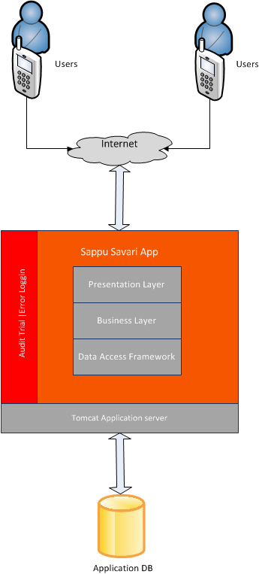

Figure 3: Software Architecture

Figure 4: Table of Available Components

|  |  |
| --- | --- |
| Component | Description |
| Application | Accessed by authenticated Users. |
| Tomcat Web Server | Application server which hosts application. |
| MySQL DB | Relational database used to store data captured in the business process. |
| File Repository | Used to store uploaded images like advertisement images/ product images/ User profile images. |

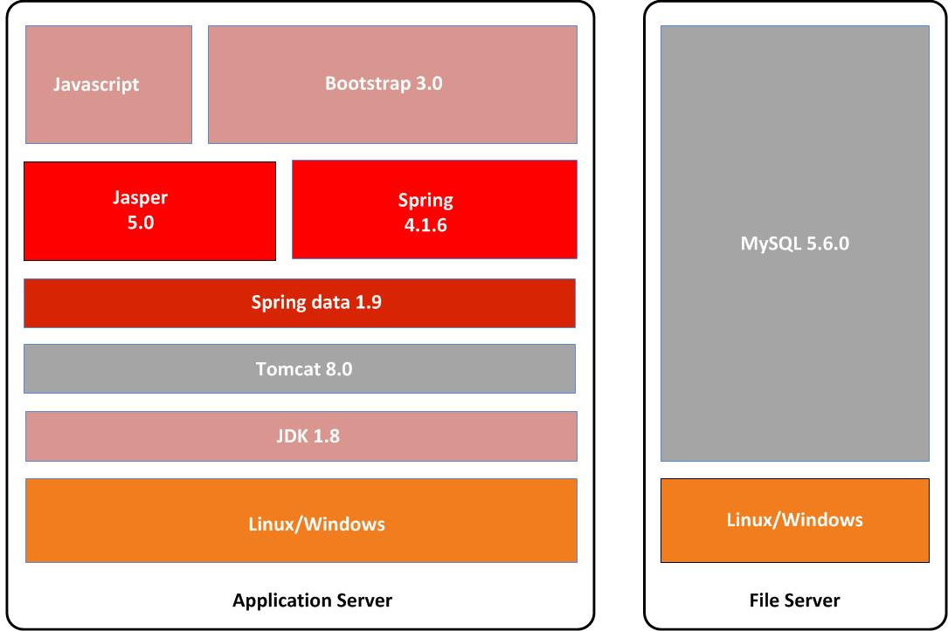

Figure 5: Technology Stack

### 5.2.4 Detailed Component Design

Component Design deals with designing different components of a software system in layered architecture. It shows structural relationships between various components in a system. In “Sappu Savari” System, Component Design Diagram shows different components of a module and their relationship in terms of interaction.

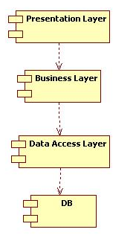

Figure 6: Component Design

### 5.2.5 Detailed Program Sequence

A sequence diagrams is a UML diagram that depicts interactions among various application components or participants over time, including but not limited to system objects, actors, and other systems or services, in order to accomplish a task. It shows object interaction in time sequence.

1. Login - see Appendix A Login User
2. Post advertisements - see Appendix A Post advertisement
3. Search advertisements - see Appendix A Search advertisement
4. Rank advertisements - see Appendix A Rank advertisement
5. Comment on advertisements - see Appendix A Comment advertisement
6. Mark Favorite advertisements - see Appendix A Mark Favorite advertisement
7. Send messages to the users - see Appendix A Send messages

### 5.2.6 Detailed Program Specification

Class diagram is a structure diagram that describes the structure of a system by showing the system's classes, their attributes, and the relationships between the classes.

#### 5.2.6.1 Class diagram For Application

This class diagram shows all the important classes with their attributes and methods pertaining to the application.

See Appendix B – Figure 14: Class Diagram

#### 5.2.6.2 ER diagram For Application

This ER diagram shows all the tables with their attributes. This ER diagram is reverse engineered from the actual database of the application. This consists of all the data types and the relationships between each table.

See Appendix C – Figure 15: ER Diagram – Database Level

### 5.2.7 Deployment View

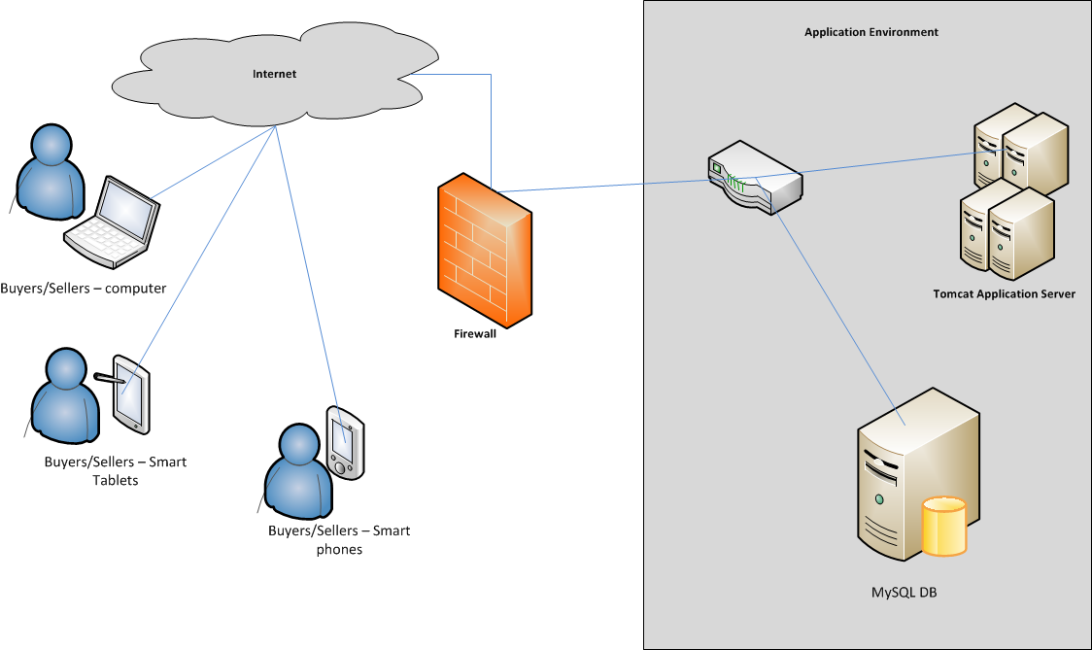

Figure 7: Deployment View

### 5.2.8 Implementation Model

#### 5.2.8.1 Package Structure

Following package Structure will be implemented for application development.

Figure 8: Table of Package Structure

|  |  |
| --- | --- |
| Application Layer | Package |
| Web Layer | com.isd.sappu.savari.controller |
| Business Layer | com.isd.sappu.savari.service |
| DAO Layer | com.isd.sappu.savari.dao |
| Model Object Layer | com.isd.sappu.savari.model |

#### 5.2.8.2 Folder Structure

Following Folder Structure will be implemented for application development.

Figure 9: Table of Folder Structure

|  |  |
| --- | --- |
| Content | Folder Structure |
| JSP Files | WEB-INF/views/content |
| Images | /images |
| Java Scripts Files | /js |
| Style Sheet Files | /css |

## 5.3 Summary

The proposed system will be develop and deploy on open source technologies.

Mainly backend of the system will be develop by Java and Spring framework. Spring framework consists of different layers which are provided different functionalities [17]. Proposed system security handled by the Spring security which is more reliable and robust for web security [18]. For web oriented functionalities Spring front end controller will be used. Also for the backend database layer Spring Data JPA [19] will be used. The goal of Spring Data JPA and repository abstraction is to significantly reduce the amount of boilerplate code required to implement data access layers for various persistence stores [19]. This will increase the efficiency of implementation and maintain overhead.

In the next chapter I will discuss detailed information about the implementation according to the analysis and design I have gone through in this chapter. The user interfaces, source code, algorithms will be described in detail on following chapter.

# Chapter 6

# Sappu Savari – Implementation

## 6.1 Introduction

In previous chapter I discussed about the design of the proposed system. The technologies I am planning to use and the finalized architectural design were discussed in detail. In this chapter includes the detail information of the implementation of the software system. The user interfaces and the algorithms and logics I need to use for the implementation are included in this chapter. Component wise how coding will be used and what design patterns will be used in which area is described in detail within this chapter.

## 

## 6.2 Implementation of the Sappu Savari

System is design to be developed by open source technologies. The tools using for the implementation process also open source.

For the Database layer MySQL database and Java will be used. For further functionalities such as connection pooling, maintain scalability Spring data JPA framework layer will be used.

For the Business layer will be developed using Java and Spring framework.

The presentation layer will be developed using JSP, JSTL, JQuery and BootStrap.

Additionally Jasper reporting will be used for report generations.

Eclipse, MySQL workbench, Ireport, Chrome web browser will be used as development tools for the newly proposed system.

## 6.3 Summary

Proposed system is based on open source technologies. From the implementation to deployment open source technologies and open source tools are used.

In the next chapter includes information on related to test, further development and conclusion of the proposed system.

# Chapter 7

# Discussion

## 7.1 Introduction

In previous chapter I discussed the implementation of the system. The wireframes, logics and algorithms I used for different business logics were discussed in detail in previous chapter.

This chapter includes the testing of the proposed solution. Also includes the specialty and difference of the system over existing advertising and marketing system. When I am implementing this concept to the real world what should be done in the future and further development on the project will be discussed in this chapter.

## 7.2 Discussion

The newly proposed system ‘Sappu Savari’ will be well benefited to the people who spend a busy schedule in their life. The time spending on browsing through the posted advertisements and allocate time and venue for meet and investigate are not needed any more for users; they can buy or sell on their day to day life. Users notify automatically when the best matching seller or buyer comes nearby, so the user will be free of tension and stress of searching the proper buyer or seller to contact. System notification will be included the contact details of the buyer or seller and shortest path details to find the other party. Until you find the best matching seller or buyer the system will continue finding.

If the user needs to find the matching goods or services manually, the system also allows the user to browse through the advertisements. Buyers can rank the sellers for future references which help other buyers to find better sellers.

The users need average computer literacy to use the system. To experience the best of the system user will need a smart phone with internet connection and location facilities. Also internet connection and satellite signal for location facility need should be available and reliable to operate the system properly.

The whole system will need a high performance web servers and database servers to serve no of users at once. Also web servers will need a higher bandwidth network since huge amount of data needed to transfer between web server and clients.

## 7.3 Summary

The objective of this newly proposed system is to provide a better and efficient service to the users than existing available internet based advertising and marketing systems. The system mainly focuses for user’s geo location information and provides better informative information from the system. Also automated processes will relief the users from overhead of searching proper advertisements over and over again; system provides notifications when there are proper match is available.

# Chapter 8

# References

|  |  |
| --- | --- |
| [1] | K. ZICKUHR, "Location Based Services," PewResearchCenter, 12 9 2013. [Online]. Available: http://www.pewinternet.org/2013/09/12/location-based-services/. [Accessed 21 11 2015]. |
| [2] | H. Bray, 30 5 2014. [Online]. Available: http://blogs.discovermagazine.com/crux/2014/04/30/how-location-based-apps-will-shape-the-future-of-shopping/#.Vk9KZ3YrLDd. [Accessed 24 8 2015]. |
| [3] | A. Grill, "londoncalling.co," [Online]. Available: http://londoncalling.co/2008/05/location-based-advertising-introduction/. [Accessed 10 11 2015]. |
| [4] | E. Corporation, "Closs 5," Ebay Pvt(Ltd), [Online]. Available: https://www.close5.com/. [Accessed 3 9 2015]. |
| [5] | D. Olandff, 12 7 2012. [Online]. Available: http://thenextweb.com/apps/2012/07/05/yardsale-for-ios-might-be-the-quickest-way-to-sell-all-of-the-stuff-sitting-around-your-house/. [Accessed 11 8 2015]. |
| [6] | A. Popescu, "W3C," Google, Inc, 11 7 2014. [Online]. Available: http://dev.w3.org/geo/api/spec-source.html. [Accessed 12 8 2015]. |
| [7] | "W3Schools.com," W3Schools.com, [Online]. Available: http://www.w3schools.com/html/html5_geolocation.asp. [Accessed 12 9 2015]. |
| [8] | G. Inc, "Google Maps Directions API," Google Inc, [Online]. Available: https://developers.google.com/maps/documentation/directions/intro. [Accessed 21 11 2015]. |
| [9] | ikman.lk, "ikman.lk," ikman.lk, [Online]. Available: http://ikman.lk/en/help/about. [Accessed 20 10 2015]. |
| [10] | O. Marketplace, "Oodle Marketplace," Oodle Marketplace, [Online]. Available: http://www.oodle.com/info/about/. [Accessed 8 10 2015]. |
| [11] | H. L. Solutions, "http://hitlanka.com/," Hit Lanka Solutions, [Online]. Available: http://hitlanka.com/web-advertising-online-buy-and-sell-best-free-classifids-website-in-sri-lanka.html. [Accessed 8 11 2015]. |
| [12] | marketplace.lk, "marketplace.lk," marketplace.lk, [Online]. Available: http://marketplace.lk/en/static/index/id/3. [Accessed 8 11 2015]. |
| [13] | B. Jiang, "Location-based services and GIS in perspective," 2006. [Online]. Available: http://citeseerx.ist.psu.edu/viewdoc/download?doi=10.1.1.66.3566&rep=rep1&type=pdf. [Accessed 8 11 2015]. |
| [14] | A. Buczkowski, "http://geoawesomeness.com/," 2012. [Online]. Available: http://geoawesomeness.com/knowledge-base/location-based-services/location-based-services-applications/. [Accessed 8 11 2015]. |
| [15] | B. Media, "http://www.geocomm.com/," [Online]. Available: http://www.geocomm.com/channel/mobile/airflashsurvey/. [Accessed 8 11 2015]. |
| [16] | B. Bosomworth, "Mobile Marketing Statistics 2015," 22 8 2015. [Online]. Available: http://www.smartinsights.com/mobile-marketing/mobile-marketing-analytics/mobile-marketing-statistics/. [Accessed 20 11 2015]. |
| [17] | H. Gupta, "dzone.com," 10 7 2010. [Online]. Available: https://dzone.com/articles/spring-framework-architecture. [Accessed 20 11 2015]. |
| [18] | L. T. Ben Alex, "docs.spring.io," [Online]. Available: https://docs.spring.io/spring-security/site/docs/3.0.x/reference/springsecurity.html. [Accessed 20 11 2015]. |
| [19] | T. D. C. S. Oliver Gierke, "2015," 15 11. [Online]. Available: http://docs.spring.io/spring-data/jpa/docs/current/reference/html/. [Accessed 21 11 2015]. |

# 

# Chapter 9

# Appendix

## 9.1 Appendix A – Sequence Diagrams

### 9.1.1 Login User

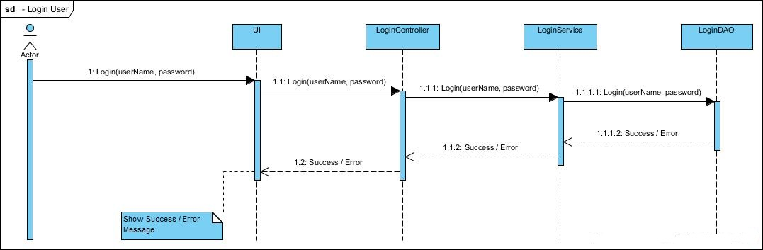

Figure 10: Login User - Sequence Diagram

### 9.1.2 Post Advertisement

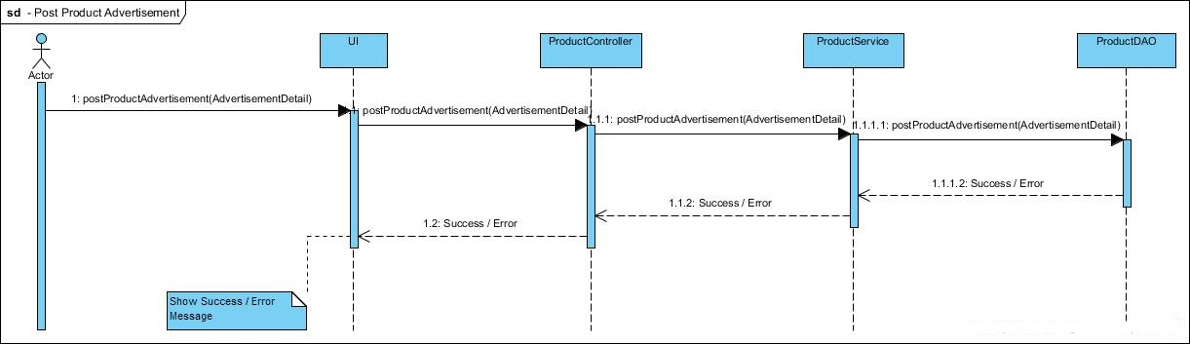

Figure 11: Post Advertisement - Sequence Diagram

### 9.1.3 Search Advertisement

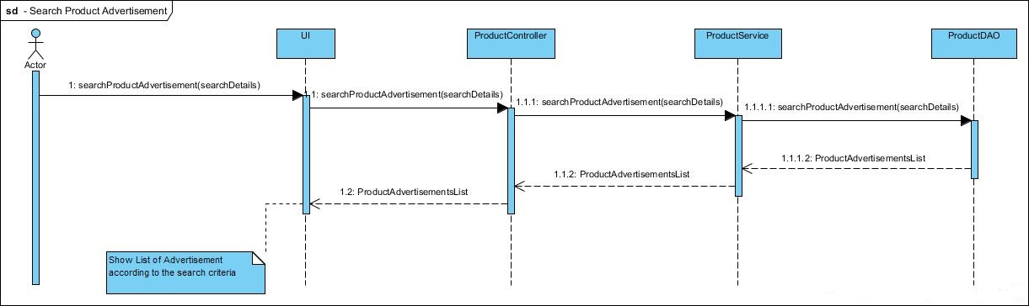

Figure 12: Search Advertisement - Sequence Diagram

### 9.1.4 Rank Advertisement

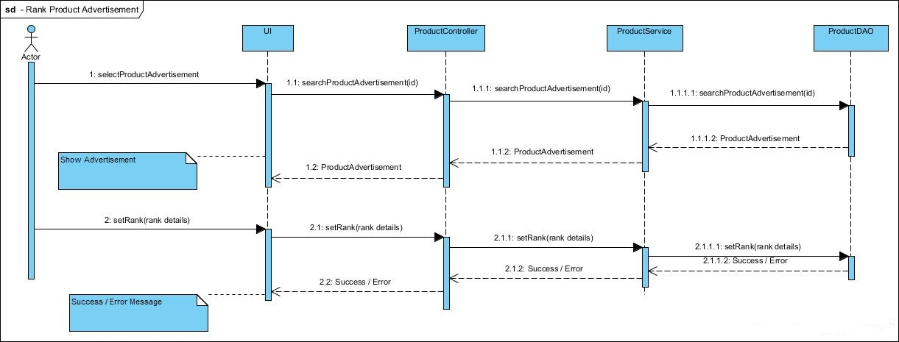

Figure 13: Rank Advertisement - Sequence Diagram

### 9.1.5 Comment on Advertisement

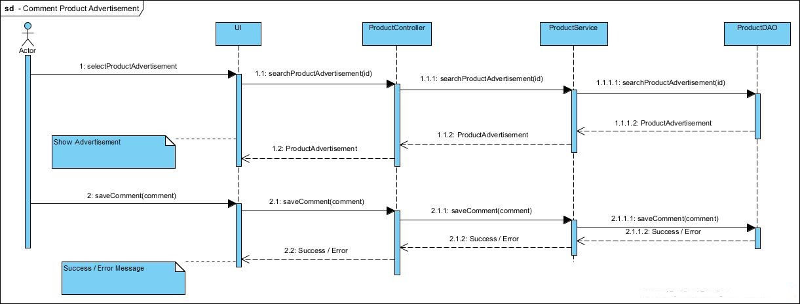

Figure 14: Comment on Advertisement - Sequence Diagram

### 9.1.6 Mark Favorite Advertisement

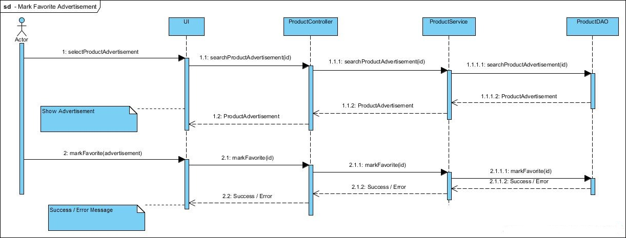

Figure 15: Mark Favorite Advertisement - Sequence Diagram

### 9.1.7 Send Messages

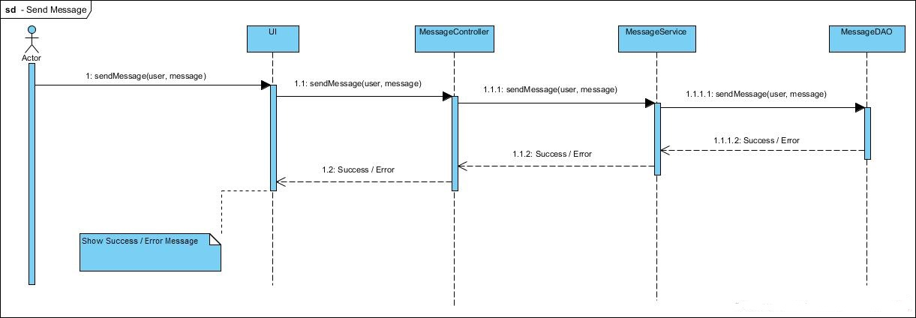

Figure 16: Send Messages - Sequence Diagram

## 9.2 Appendix B

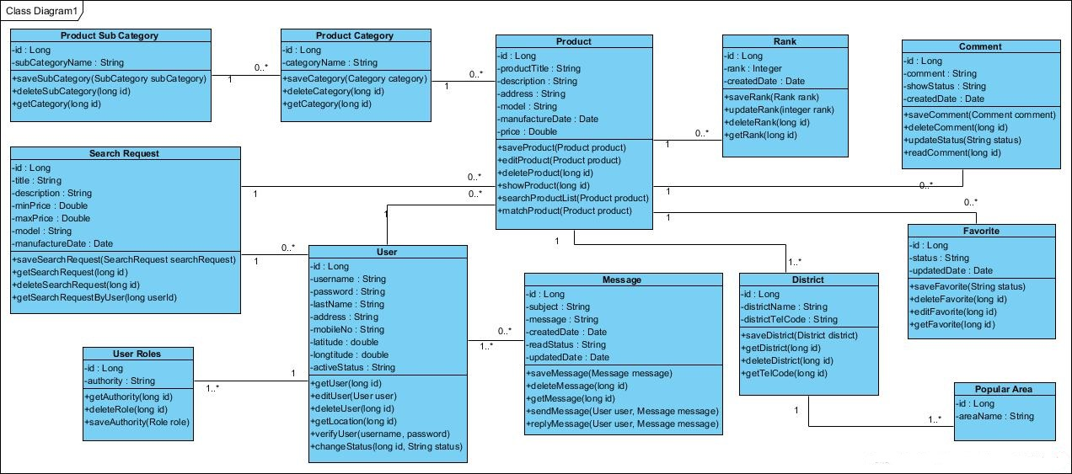

Figure 17: Class Diagram

## 9.3 Appendix C

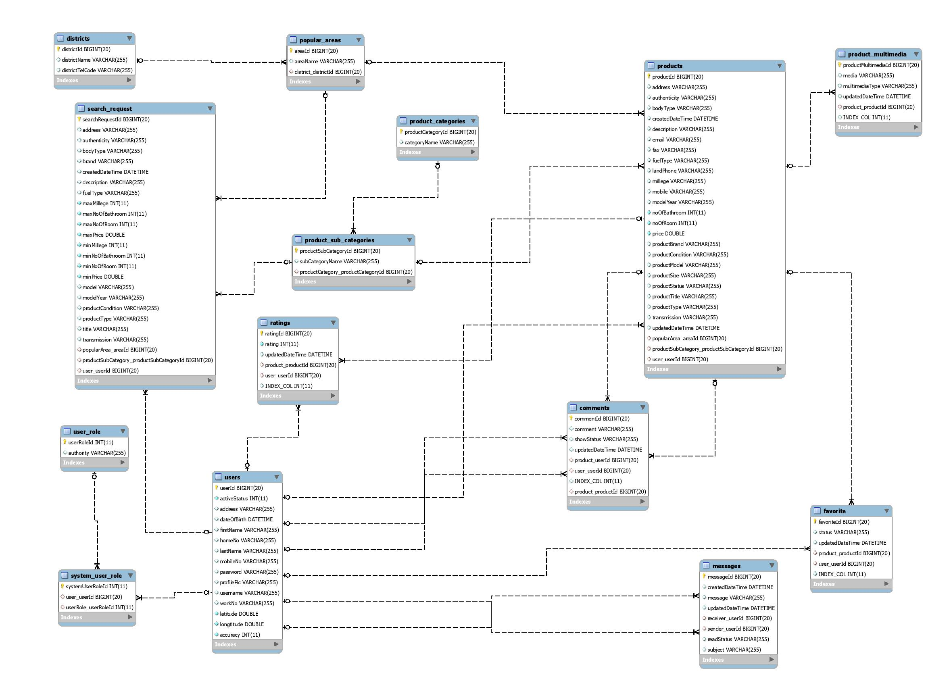

Figure 18: ER Diagram - Database Level